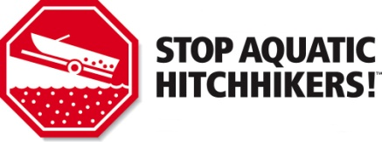
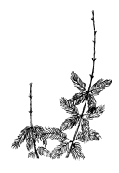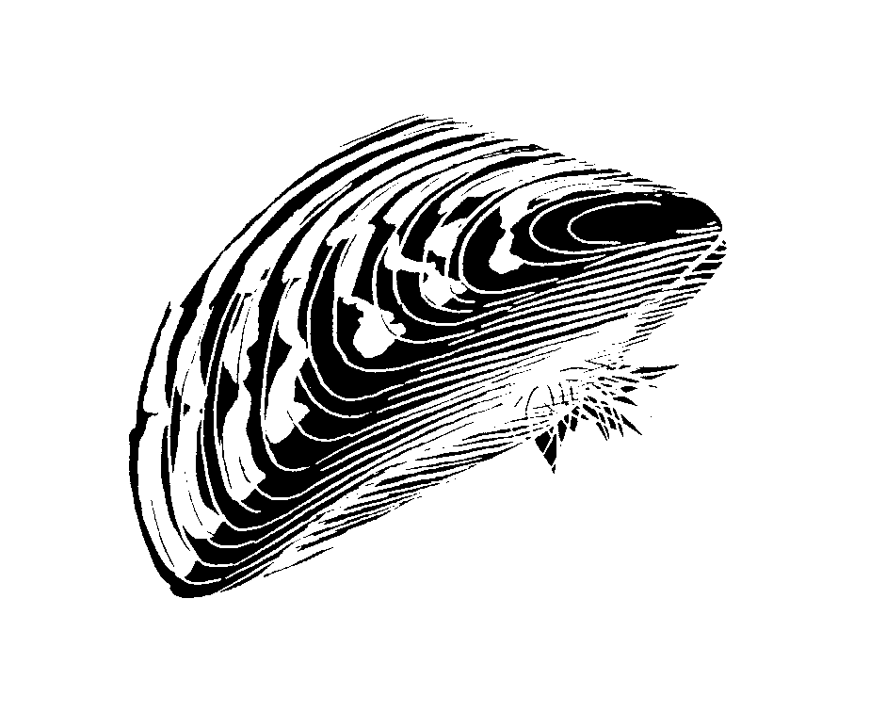
Dear Visitor to [insert name of lake or resort/campground] and the Hubbard County Region

Minnesota is known for its clean water, good fishing, and incredible recreational opportunities and we hope to keep it that way for your future visits and for future generations.

There are several invasive species that are causing problems in the lakes, rivers and forests across the country. Aquatic invasive species such as Eurasian watermilfoil, zebra mussels, faucet snails, and hydrilla can harm water recreation and fish populations. Boaters and anglers often unknowingly transport these species as they travel to different lakes and rivers. Visitors might also unknowingly bring unwanted forest pests such as emerald ash borer along to Minnesota in their firewood or on their gear.

Help protect [insert name of lake or resort/campground] and Hubbard County from AIS infestations. Please keep these points in mind before you visit our Hubbard County regional lakes and before transporting watercraft and firewood.

In Minnesota, you must:

Inspect your boating equipment. Clean visible aquatic plants, zebra mussels and other prohibited species off of watercraft, trailers, and equipment before transporting from any water access.
Drain water from the bilge, live wells, motor, bait wells, and ballast tanks while on land before leaving any water access or shoreline property. Tilt motor down to drain water. Personal watercraft users should briefly run the powertrain to expel all water.
Keep drain plug out and water-draining devices open while transporting watercraft.
Dispose of all unwanted bait in the trash or Drain water from bait containers and replenish with bottled or tap water. Never release your live bait into a waterbody, or release aquatic animals from one waterbody into another. Do not dispose of your bait on the ground, which is considered littering.

Additional recommended precautions, not required by law:

Rinse/Spray/Dry your boat, tackle, trailer, and other boating equipment to kill or remove harmful species that were not visible at the boat launch. This can be done on your way home or once you have returned home. Commercial car washes with self-cleaning stations are good facilities to use. Some aquatic invasive species can survive more than 2 weeks out of water, so it is important to do one or more of these before transporting boats and equipment to another waterbody
- Rinse your boat and equipment that normally gets wet with hot (at least 120 degrees F) tap water; or
- Spray your boat hull, motor, and trailer with high-pressure water; or
- Dry your boat and equipment for at least 5 days.
Decontamination is recommended at a DNR designated wash station if you are leaving a
waterbody that is infested with zebra mussels.
Don’t transport firewood. Rather than bringing firewood to your campground or cabin, buy locally grown and “DNR approved” firewood at the campground or in the town you’ll be visiting.
- Clean mud, seeds and plant parts from your OHVs, ATVs, bikes, boots, pets and camping gear before transporting to prevent spread of weeds and other invasive species.

For more information, visit www.mndnr.gov/invasives

We are looking forward to your visit. COLA 2015
Sincerely, [insert name of lake or resort/campground]

